**SCALA PROGRAMMING**

**NAME : M.SAI SATHVIKA REDDY**

**USN : 22BTRAD024**

**CSE AI DE**

Write a Scala program to check two given integers, and return true if one of them is 30 or if their sum is 30.

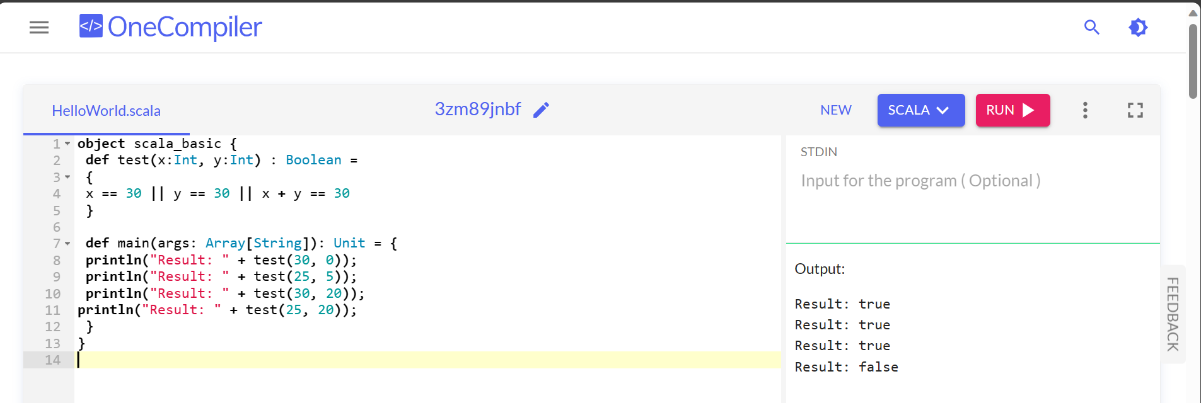

CODE:

object scala_basic {

def test(x:Int, y:Int) : Boolean =

{

x == 30 || y == 30 || x + y == 30

}

def main(args: Array[String]): Unit = {

println("Result: " + test(30, 0));

println("Result: " + test(25, 5));

println("Result: " + test(30, 20));

println("Result: " + test(25, 20));

}

}